# INTRODUCTION

* 1. Overview

We have used zoho books to maintain financial reports and billings of our company(fresh bites catering)

* 1. Purpose

To provide complete details of companyies financial reports

1. **Problem Definition & Design Thinking**
   1. Empathy Map

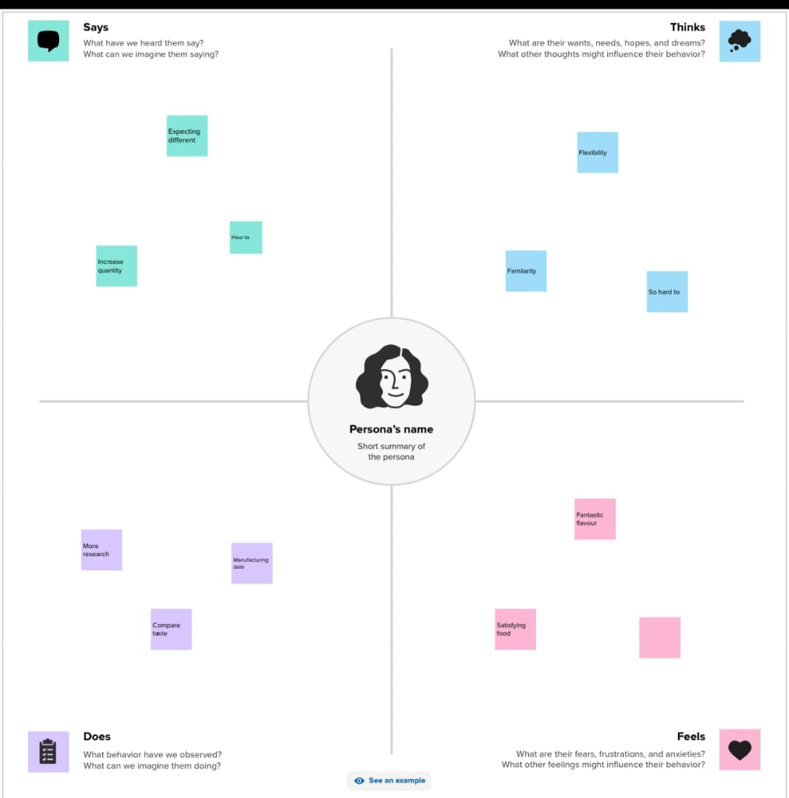

* 1. Ideation & Brainstorming Map

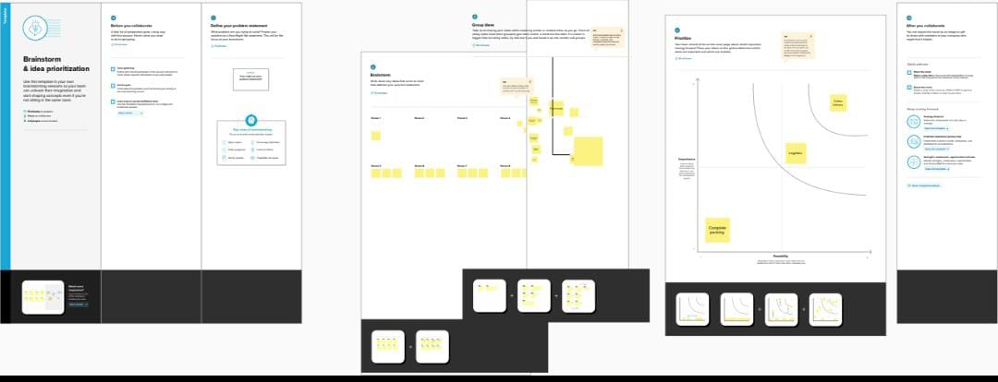

# RESULT

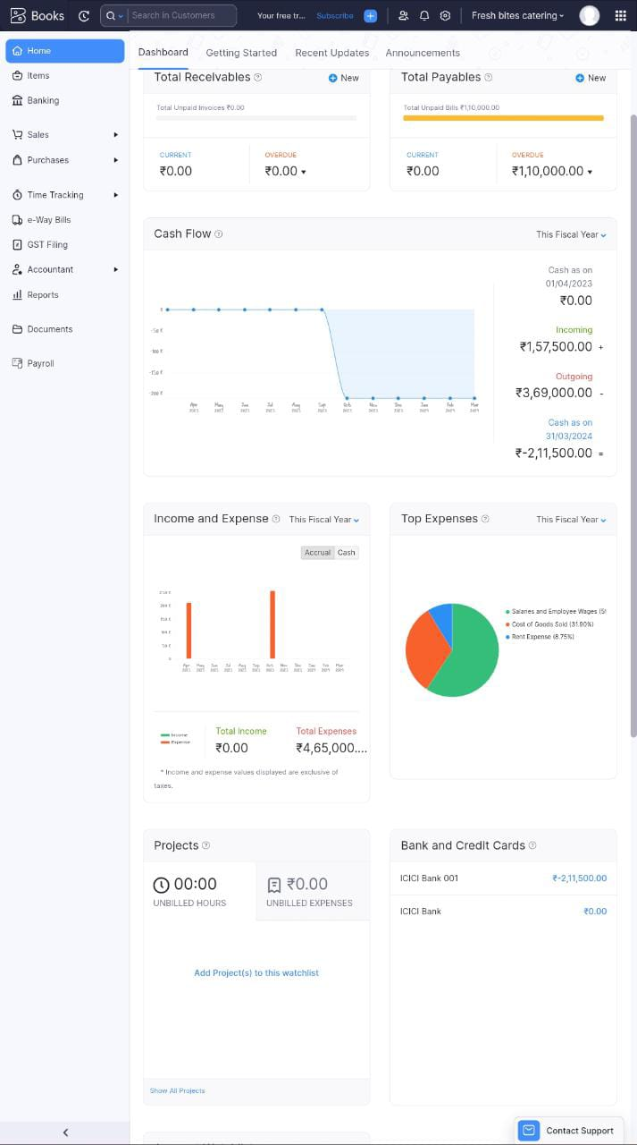

# ADVANTAGES & DISADVANTAGES

* Good relationship with customer
* Freshly prepared foods
* Hygienic food

Disadvantages:

* Risk involved in the company
* Financial risks are frequent

# APPLICATIONS

This application can be used to make financial reports of the company and record billings and expenses

# CONCLUSION

So we conclude that this project is been done by using zoho books and we came to know how to make reports i.e financial report of the company

# FUTURE SCOPE

We ensure you to provide with good services and provide healthy products to the customers.